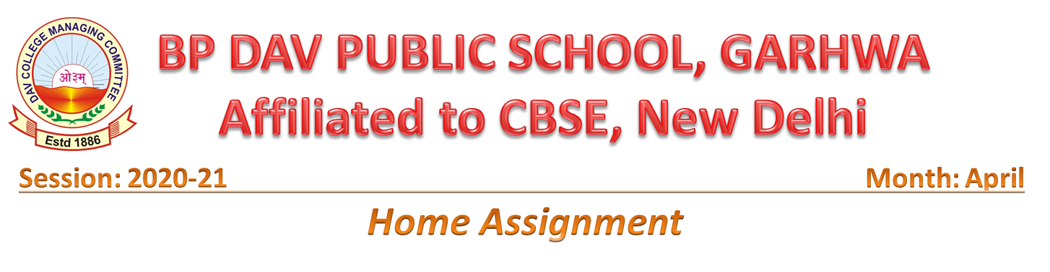
Class: 1 Subject- EVS
1. My self (fill in the blanks and learn it)
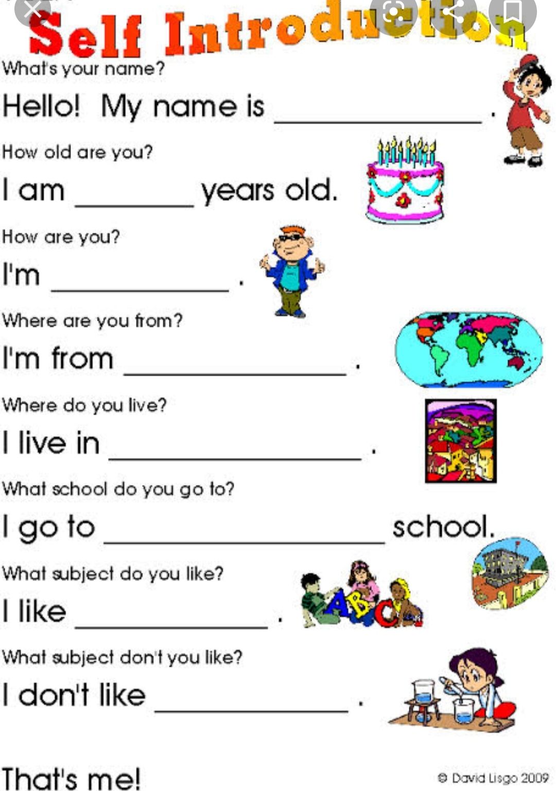
2. Write and learn with spelling body parts.
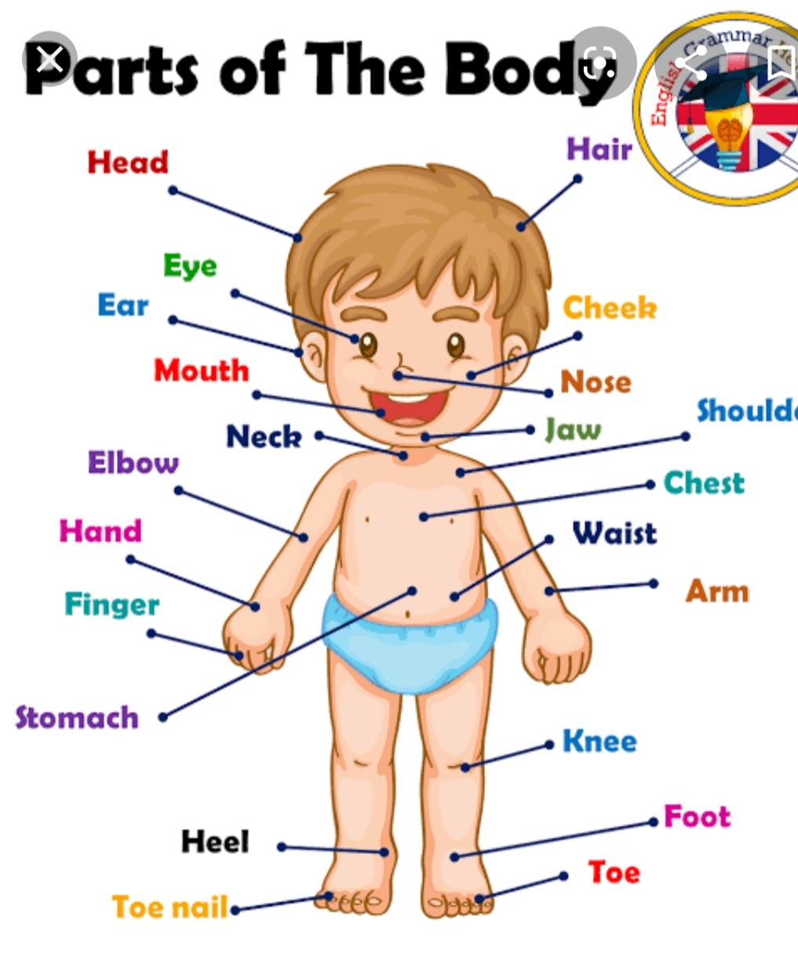
3. Paste or draw 5 objects which help us to keep clean. https://youtu.be/-CIYTf7Oky4
4. Sense organs (learn it).
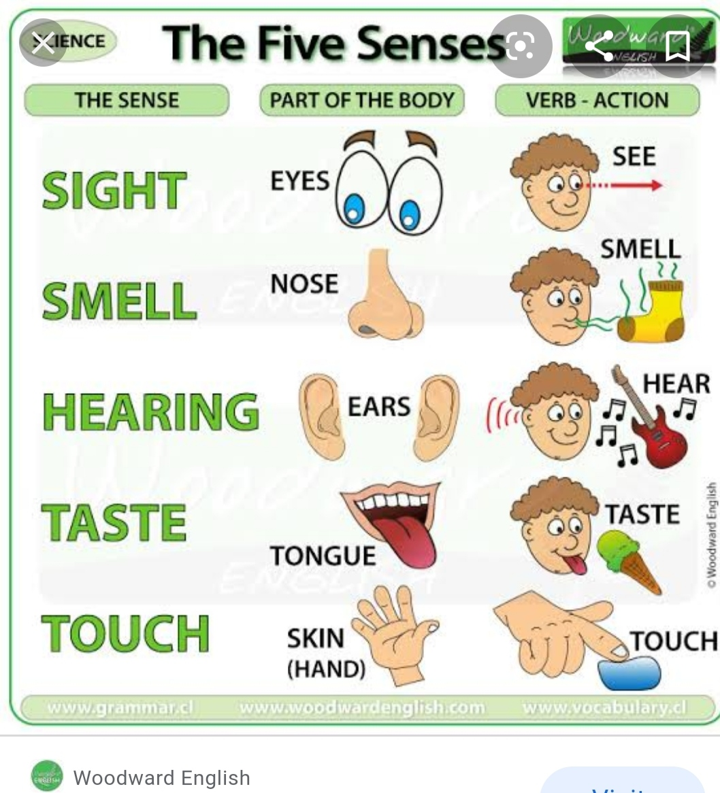
Class 1 Subject - English
1. Write and learn 5 lines on "My school".
2. One page handwriting everyday.
3. One and many (learn and write).
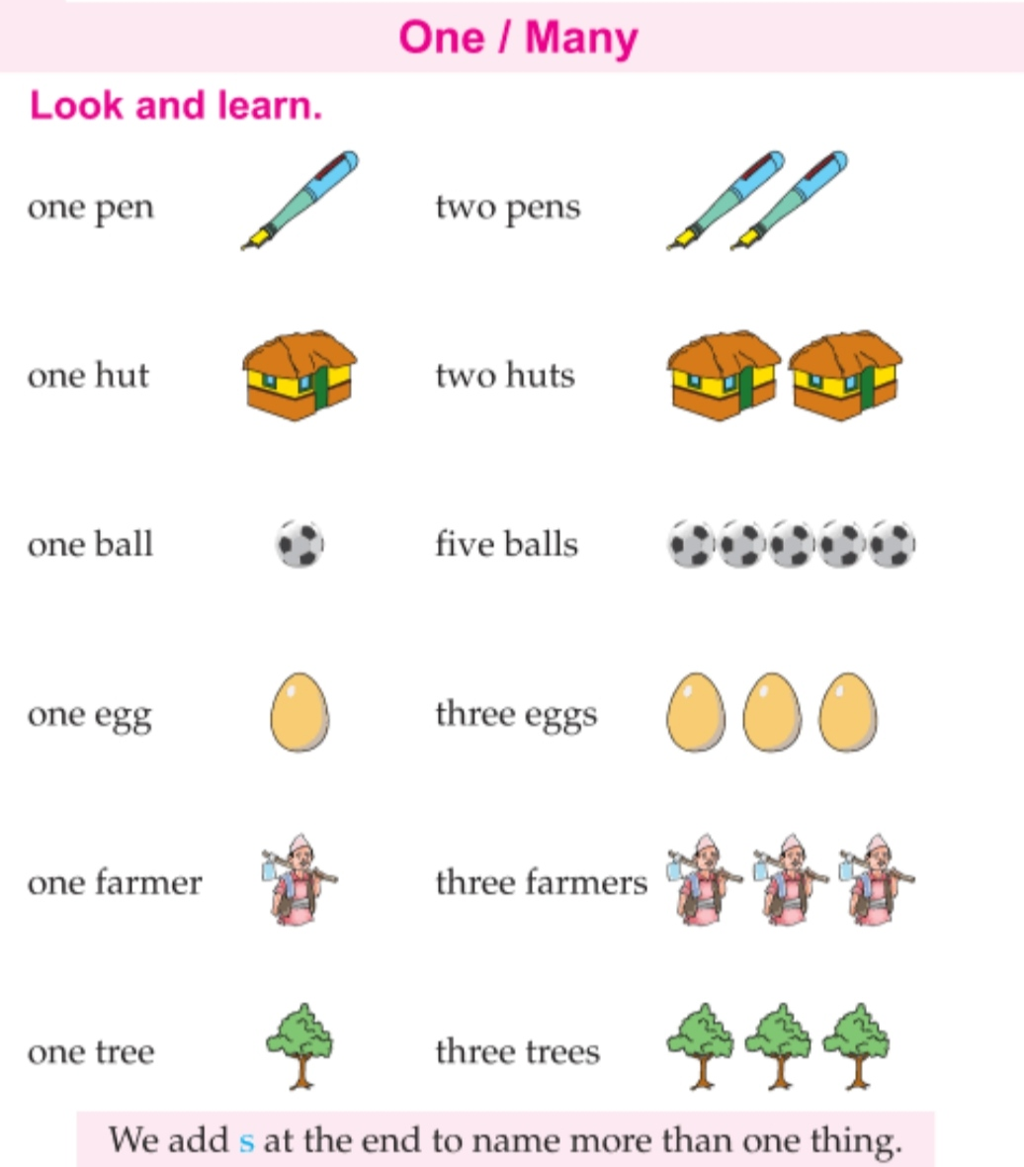

4. Noun or naming word (Learn it ) https://youtu.be/c292_2_W-hc

Class 1 subject- Hindi
- अ, आ, इ, ई की मात्रा वाले 5-5शब्द चित्रों के बनाएं
- तीन और चार अक्षर वाले 10-10 शब्द लिखें
- उलटे या विलोम शब्द याद करें https://youtu.be/3uqy3Gf2o10
- प्रतिदिन एक पेज सुलेख लिखें
Class: 1 Subject-maths
1. Write and learn the forward counting 1 to 100.
2. Comparison (Big and small)
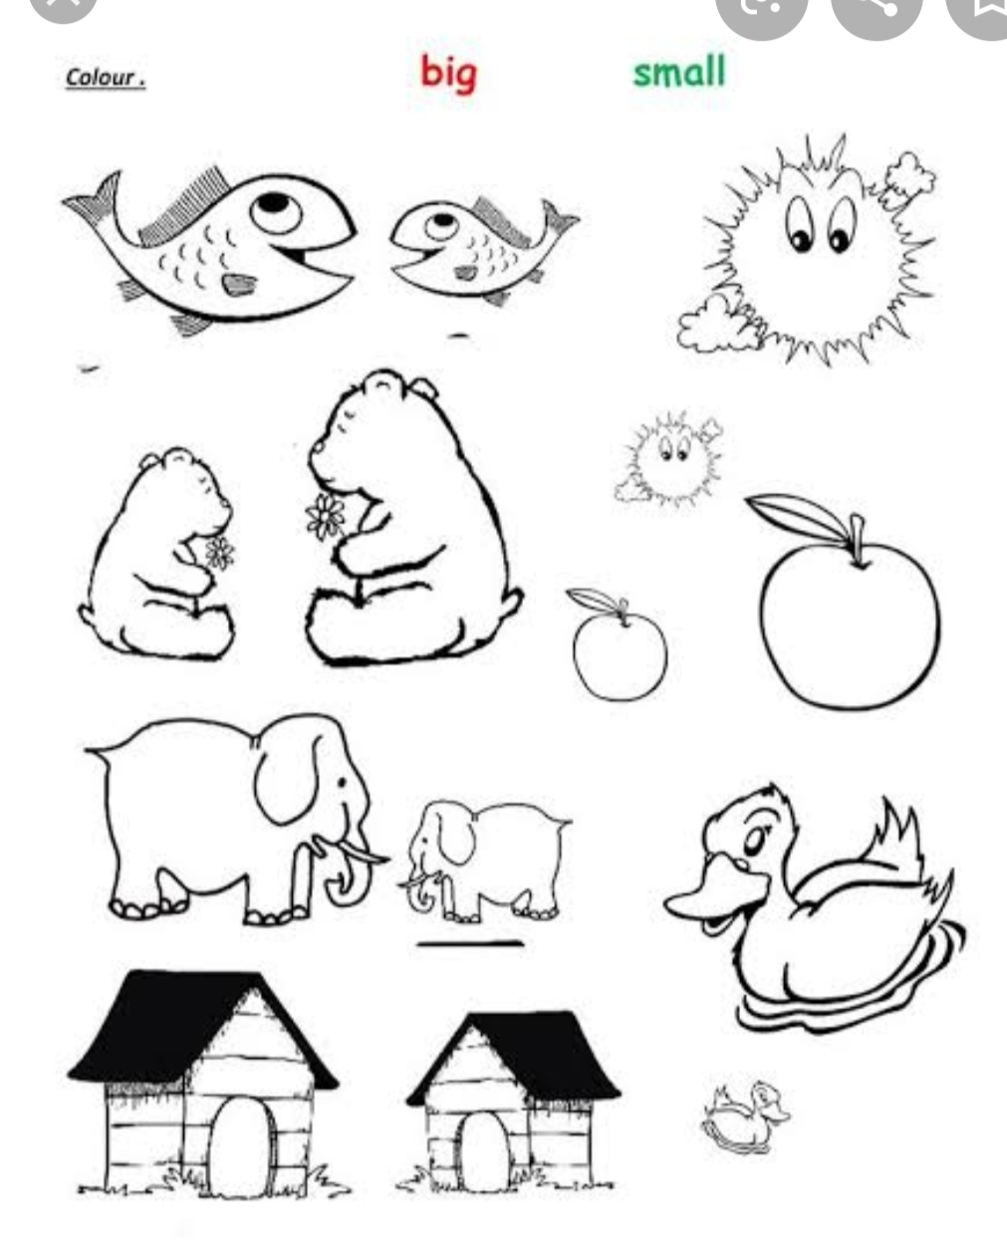
3. Insert the missing numbers.
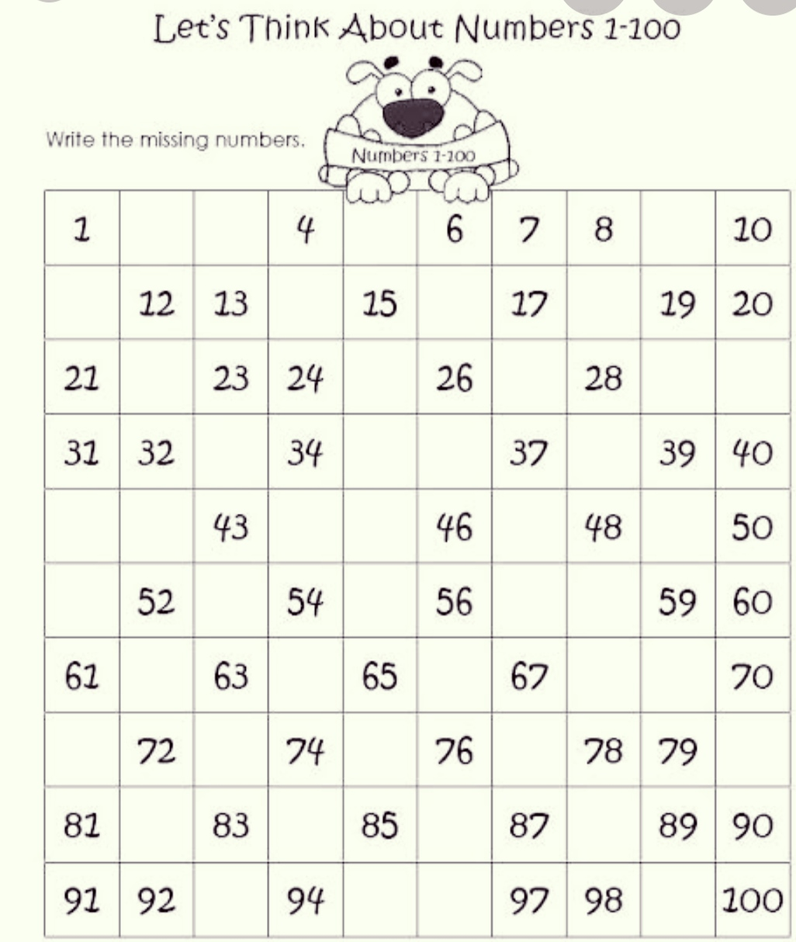
- Write and learn the number name(1 to 30)
- Learn and write table of 2 and 3.

